“Airline & Airport Operations – Flight Booking Management & Analytics Portal”
A Project Report Submitted in the partial fulfillment of the requirements for the award of the degree of
BACHELOR OF TECHNOLOGY
In
DEPARTMENT OF COMPUTER SCIENCE ENGINEERING
&
DEPARTMENT OF COMPUTER SCIENCE AND INFORMATION TECHNOLOGY
By
L.Sainath --2520090148
M.Naman--2520090194
M.Abhi Sai Sagar--2520090173
Under the Esteemed Guidance of
M Gayatri
Assistant Professor
Department of Computer Science and Engineering
K L (Deemed to be) University
DEPARTMENT OF COMPUTER SCIENCE ENGINEERING
&
DEPARTMENT OF COMPUTER SCIENCE AND INFORMATION TECHNOLOGY
Declaration
The Project Report entitled “Airline & Airport Operations – Flight Booking Management & Analytics Portal” is a record of Bonafide work of L.Sainath,M.Naman,M.Abhi Sai Sagar submitted in partial fulfillment for the award of B. Tech in Computer Science and Engineering (or) Computer Science and Information Technology to the K L University. The results embodied in this report have not been copied from any other departments/University/Institute.

L.Sainath
M.Naman
M.Abhi Sai Sagar
K L (Deemed to be) University
DEPARTMENT OF COMPUTER SCIENCE ENGINEERING
&
DEPARTMENT OF COMPUTER SCIENCE AND INFORMATION TECHNOLOGY
CERTIFICATE
This is to certify that the mini project based report entitled “Airline & Airport Operations – Flight Booking Management & Analytics Portal” is a bonafide work done and submitted by L.Sainath --2520090148,M.Naman--2520090194,M.Abhi Sai Sagar--2520090173
in partial fulfillment of the requirements for the award of the degree of BACHELOR OF TECHNOLOGY in Department of Computer Science Engineering, K L (Deemed to be University), during the academic year 2025-2029.

Signature of the Guide
Signature of the Course Coordinator Signature of the HOD
ACKNOWLEDGEMENT
The success of this project would not have been possible without the timely help and guidance rendered by many people. We wish to express our sincere thanks to all those who assisted us in one way or the other for the completion of our project.
Our greatest appreciation goes to our Course Coordinator M Gayatri
and our project guide M Gayatri ,Department of Computer Science & information technology , for their tremendous support, encouragement and guidance throughout the development of this project.
We express our gratitude to Khaja Shareef, Head of the Department, for providing us with adequate facilities, ways and means by which we were able to complete this project-based lab.
We thank all the teaching and non-teaching staff members who assisted us directly or indirectly in the successful completion of this project. Finally, we sincerely thank our parents, friends and classmates for their kind help and cooperation during our work.
L.Sainath --2520090148
M.Naman--2520090194
M.Abhi Sai Sagar--2520090173
Abstract
Airline and airport operations involve large amounts of flight, passenger, booking and seat-availability information. When these activities are handled through scattered records or manual processes, searching for flights, maintaining bookings, checking seat availability and preparing operational reports become time-consuming and error-prone. To address this problem, our project focuses on the design and development of an “Airline & Airport Operations – Flight Booking Management & Analytics Portal”.
The proposed system provides a centralized, database-driven environment for managing flights, passengers, bookings and airports. Users can search for available flights and create bookings, while the system automatically maintains booking and seat information. The portal also provides analytics on daily booking counts, route-wise bookings, seat utilization and on-time flight performance, converting stored operational data into useful information for monitoring and planning.
The system follows a simple Input → Processing → Database → Output workflow. The frontend is developed using HTML, CSS, JavaScript and Bootstrap. Python with Flask is used for backend processing, MySQL is used for structured data storage and MySQL Workbench is used for database management. The project also studies algorithmic techniques such as Dijkstra’s algorithm, A* search, Greedy algorithms and hashing in the context of routing, selection and fast lookup.
In summary, the project demonstrates how web development, relational database management, booking workflows and operational analytics can be integrated into a single academic prototype for airline and airport operations.
Index
S. No. | Chapters | Topics | Page no.
 | Acknowledgement |  | 4
 | Abstract |  | 5
1 | Introduction | 1.1 Background of the project  1.2 Problem statement  1.3 Scope of the project  1.4 Objective(s)  1.5 Importance of the application  1.6 Target users/audience | 8
2 | System Requirements | 2.1 Hardware requirements  2.2 Software requirements  2.3 Development tools and frameworks | 11
3 | Technology Stack | 3.1 Front-end  3.2 Back-end  3.3 Database  3.4 Version control  3.5 APIs or external services | 12
4 | System Architecture | 4.1 High-level architecture diagram  4.2 Description of each layer  4.3 Deployment architecture | 14
5 | Design | 5.1 Workflow design  5.2 ER diagram / Database schema  5.3 Calculations and analytics | 15
6 | Implementation | 6.1 Module-wise implementation  6.2 Front-end logic  6.3 API integration  6.4 Authentication & authorization | 17
7 | Features | 7.1 List of main features  7.2 How each feature works | 19
8 | Testing | 8.1 API testing  8.2 Integration testing  8.3 Tools used for testing  8.4 Test cases and results | 20
9 | Deployment | 9.1 Steps to deploy  9.2 Environment configuration  9.3 Hosting of frontend and backend | 21
10 | Challenges & Limitations | 10.1 Issues faced during development  10.2 Solutions applied  10.3 Current limitations or known bugs | 22
11 | Future Enhancements | 11.1 Planned features  11.2 Possible integrations or optimizations | 23
12 | Conclusion | 12.1 Summary of the project  12.2 What was achieved  12.3 Skills learned during development | 24
13 | References | Books, tutorials, APIs, documentation sites and research papers used | 25
14 | Appendices | Screenshots; sample code snippets; installation/setup instructions; user manual; geo-tag photos with guide; review forms with guide signatures | 26

CHAPTER -1 INTRODUCTION
1.1 Background of the Project
Airline and airport operations depend on timely and accurate management of flight schedules, passenger records, bookings, airport information and seat capacity. As the number of flights and passengers increases, manual handling of these records makes searching, updating and reporting difficult. A centralized digital system provides a structured way to store operational information and support routine booking activities.
The proposed “Airline & Airport Operations – Flight Booking Management & Analytics Portal” is a database-driven web application that combines flight booking management with operational analytics. Instead of treating booking and reporting as separate activities, the system stores booking transactions in a relational database and uses those records to calculate operational indicators.
The project is built around four primary entities: Flights, Passengers, Bookings and Airports. Flight records contain source, destination, schedule and seat capacity; passenger records store passenger information; booking records connect passengers with flights; and airport records provide the airport-level information required for route management.
From an academic and engineering perspective, the project combines web technologies, backend programming, relational database management and basic algorithmic techniques. User requests are processed by the Flask backend, stored in or retrieved from MySQL, and returned to the user interface (Input → Processing → Database → Output).
1.2 Problem Statement
Flight booking and airline operational information becomes difficult to manage when flight, passenger and seat data are maintained separately or manually. Searching for flights may require repeated data entry, booking records are hard to track, and seat availability may not be accurate if updates are not centralized.
Operational analysis is another challenge. Measures such as daily bookings, popular routes, seat utilization and on-time performance are valuable for monitoring and planning, but they require structured data and calculations. Without a centralized database and reporting mechanism, generating them requires additional manual effort.
The project therefore addresses the need for a single portal that combines flight search and booking management with database-backed seat information and operational analytics. The objective is not only to record bookings but also to use those records to generate meaningful summaries for airline and airport operations.
1.3 Scope of the Project
The scope covers the development of a web-based flight booking and analytics portal. The main functional scope includes:
- Management of Flights, Passengers, Bookings and Airports.
- Search and retrieval of available flight information.
- Creation and management of passenger booking records.
- Tracking of seat availability based on booking information.
- Calculation of daily booking count and route-wise bookings.
- Calculation of seat utilization and on-time flight rate.
- Use of relational database operations such as CRUD, joins and aggregation.
- Provision for algorithmic techniques relevant to routing, selection and fast lookup.
The project is an academic prototype. External airline reservation networks, live airline APIs, real payment gateways and large-scale cloud deployment are outside the confirmed scope unless separately implemented by the team.
1.4 Objectives of the Project
- To design and develop a centralized flight booking management portal.
- To store flight, passenger, booking and airport information in a structured MySQL database.
- To provide flight search and booking functionality through a web interface.
- To maintain and display seat availability information.
- To calculate daily bookings, route bookings, seat utilization and on-time performance.
- To demonstrate the use of Flask for backend processing and MySQL for persistent data management.
- To apply algorithmic techniques such as Dijkstra, A*, Greedy selection and hashing where relevant.
- To provide a foundation for future airline and airport operational analytics.
1.5 Importance of the Application
The importance of the application lies in integrating transactional booking information and operational analysis in one system. For passengers, a centralized booking workflow reduces the effort of searching for flights and recording details. For administrative users, the same stored data supports reports on bookings, routes, seat utilization and on-time performance.
The project also demonstrates an important software engineering principle: transactional data can be stored once in a structured database and reused for multiple operational reports, which reduces duplication and provides a consistent source of information.
1.6 Target Users / Audience
- Passengers who need to search and book available flights.
- Booking or administrative users who manage passenger and booking records.
- Airline/airport operational staff who require summarized booking and flight information.
- Project administrators responsible for maintaining flight, airport and passenger data.
- Academic users and researchers studying database-driven airline operations and analytics.
CHAPTER -2 SYSTEM REQUIREMENTS
2.1 Hardware Requirements
The project is a web-based academic application and can be developed and tested on a standard personal computer or laptop.
Component | Requirement
Processor | Intel Core i5 / AMD Ryzen 5 or equivalent (recommended)
RAM | 8 GB minimum for development
Storage | SSD with adequate free space for IDE, Python environment and MySQL
Display | 1366×768 or higher
Input devices | Keyboard and mouse
Network | Stable internet connection for downloading dependencies
Browser | Modern web browser (Chrome / Edge / Firefox) for testing

2.2 Software Requirements
Software | Purpose
Operating System | Windows, Linux or macOS
Python | Backend development
Flask | Web framework for routing and application logic
MySQL Server | Relational database management
MySQL Workbench | Database design and SQL administration
HTML5, CSS3, JavaScript | Frontend structure, styling and interaction
Bootstrap | Responsive interface components
VS Code / Python IDE | Code editing and debugging
Web browser | Running and testing the application

2.3 Development Tools and Frameworks
The frontend uses HTML, CSS and JavaScript for structure, styling and interaction, with Bootstrap providing responsive UI components. Python Flask provides backend routing and application logic. MySQL provides persistent relational storage, and MySQL Workbench supports schema creation, SQL queries and database administration.
The development workflow is modular: frontend requests are handled by Flask routes, business logic is executed on the server, and database queries read or modify the required records. The resulting data is then returned to the frontend.
CHAPTER-3 TECHNOLOGY STACK
3.1 Front-End Design
The frontend is the user-facing layer of the portal. HTML provides the structure of pages and forms, CSS controls layout and presentation, and JavaScript provides client-side interaction and validation. Bootstrap supports responsive layouts and reusable components.
The interface includes flight search forms, flight-result tables or cards, passenger forms, booking confirmation views and analytics displays. Form validation ensures required inputs are entered before a request is sent to the backend.
3.2 Back-End Design
Python with Flask is the backend framework. Flask receives HTTP requests from the frontend, validates inputs, applies application logic and communicates with MySQL. Routes are organized around operations such as flight search, booking creation, passenger management and analytics.
A typical request follows this sequence: Frontend request → Flask route → validation / business logic → MySQL query → Flask response → frontend display. This keeps presentation, application logic and data management separate.
3.3 Database Design
MySQL is the central relational database. The main entities are Flights, Passengers, Bookings and Airports. Primary keys uniquely identify records, while foreign keys connect related records.
- Flights: flight identifier, source and destination airport, schedule, seat capacity/availability and status.
- Passengers: passenger identifier and the details required for booking.
- Bookings: booking identifier, passenger reference, flight reference, seat information and booking status.
- Airports: airport identifier and airport information used by flight routes.
The database supports CRUD operations and SQL queries involving filtering, joins, counting and aggregation. Booking records can be joined with flight and passenger records to produce booking histories and operational summaries.
3.4 Version Control
Version control is maintained using Git with a repository on GitHub https://github.com/abhisaisagar07/Flight-Booking-Management-Analytics-Portal-for-Airline-Airport It provides a history of source-code changes, supports collaboration among team members and allows earlier versions to be restored when required.
3.5 APIs or External Services
The confirmed architecture is centered on the local Flask backend and MySQL database; no external airline API is connected in the current version. If external APIs are introduced in future, they can be integrated through Flask routes so that live flight data is fetched and normalized before being displayed. The internal Flask routes themselves act as the API layer between the frontend and the database.
CHAPTER -4 SYSTEM ARCHITECTURE
4.1 High-level Architecture Diagram
The system follows a layered architecture in which the user interacts with the browser interface, requests are processed by Flask, and data is stored and retrieved from MySQL. Analytics are derived from the same stored records.
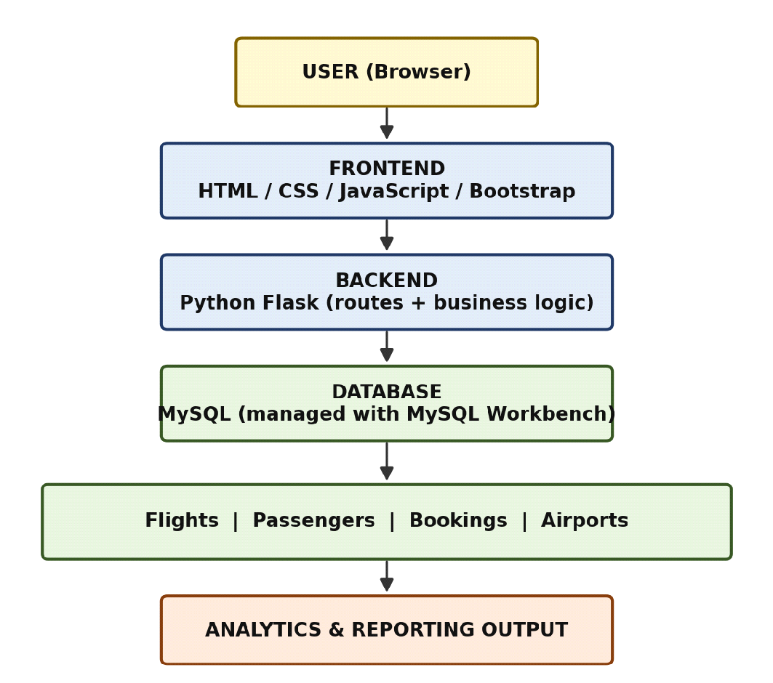

Figure 4.1: High-level architecture of the Flight Booking Management & Analytics Portal
4.2 Description of Each Layer
- Frontend Layer: accepts search, passenger and booking inputs and presents flight results, booking status and analytics using HTML, CSS, JavaScript and Bootstrap.
- Backend Layer: Flask acts as the application server. It receives HTTP requests, validates data, executes business rules and calls the database layer.
- Database Layer: MySQL stores persistent data in tables for flights, passengers, bookings and airports. SQL queries retrieve records, create bookings, update seat information and calculate reports.
- Analytics Layer: booking and flight data are aggregated to calculate daily booking counts, route bookings, seat utilization and on-time rate.
4.3 Deployment Architecture
The current project runs in a local development environment. Flask runs the web application server, MySQL runs the database service and the browser acts as the client. The default Flask URL is http://127.0.0.1:5000 (or http://localhost:5000); MySQL commonly uses port 3306. The exact ports and credentials should be taken from the application configuration [confirm]. No CI/CD pipeline or cloud deployment is used in the current prototype.
CHAPTER -5 DESIGN
5.1 Workflow Design
The system follows an Input → Processing → Database → Output workflow. User inputs such as search criteria and passenger details are validated by Flask, stored in or fetched from MySQL, and the resulting flights, booking status or analytics are returned to the user.
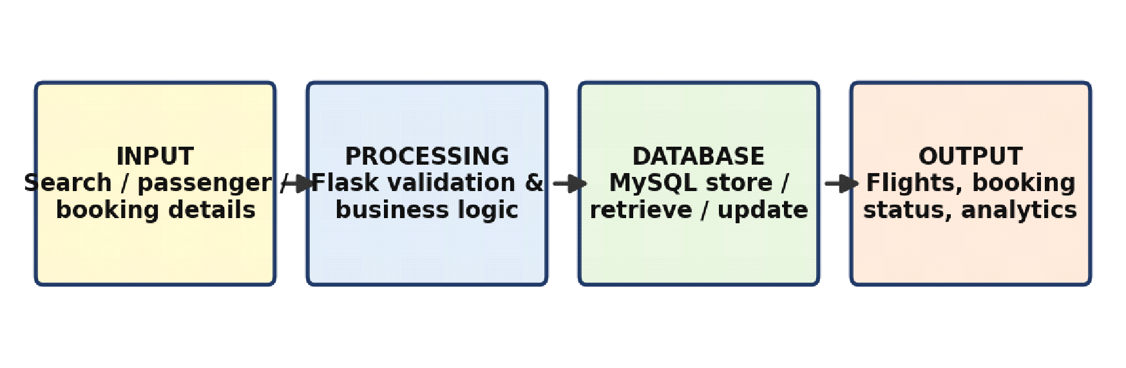

Figure 5.1: Input–Processing–Database–Output workflow
5.2 ER Diagram / Database Schema
The database contains four principal entities: Airports, Flights, Passengers and Bookings. The relationships are designed around the booking workflow.
- Airports → Flights: an airport can act as the source or destination for many flights.
- Passengers → Bookings: one passenger can have multiple bookings.
- Flights → Bookings: one flight can have multiple passenger bookings, subject to available seat capacity.
- Bookings links a passenger to a selected flight and stores the booking transaction.
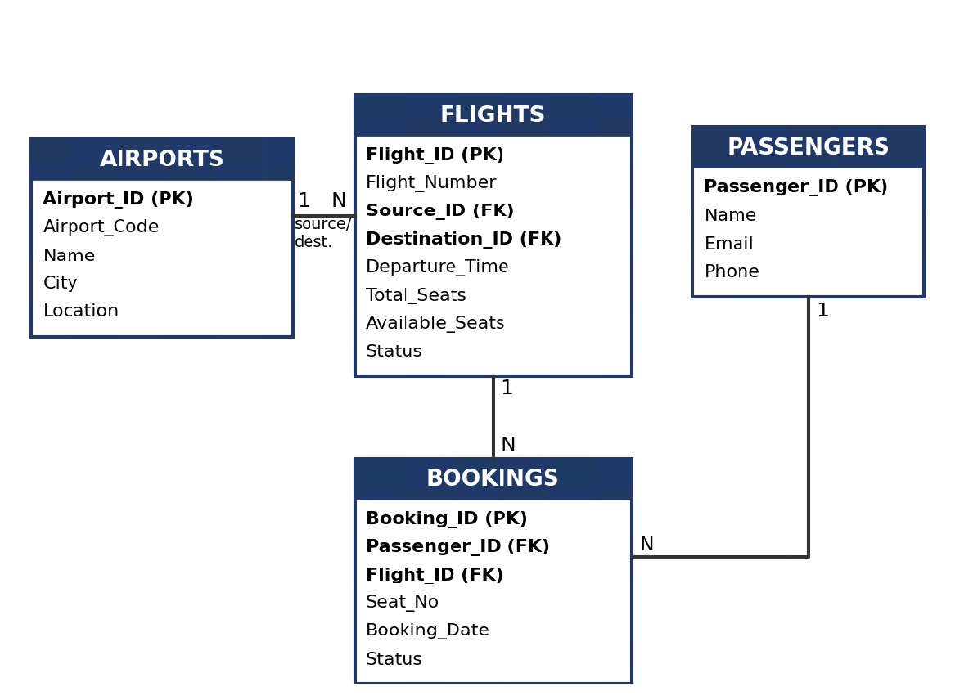

Figure 5.2: ER diagram / database schema
Entity | Primary Key | Important Attributes | Relationship
Airports | Airport_ID | Airport_Code, Name, City, Location | Referenced by Flights
Flights | Flight_ID | Flight_Number, Source, Destination, Date/Time, Total_Seats, Available_Seats, Status | Has many Bookings
Passengers | Passenger_ID | Name, Email, Phone, other required details | Has many Bookings
Bookings | Booking_ID | Passenger_ID, Flight_ID, Seat_No, Booking_Date, Status | Links Passengers and Flights

Note: column names above are the suggested schema.
5.3 Calculations and Analytics
The portal uses stored operational records to calculate the following indicators:
Indicator | Formula
Daily Booking Count | Number of booking records created on a selected date
Route Bookings | Count of bookings grouped by source and destination
Seat Utilization (%) | (Booked Seats / Total Seats) × 100
On-Time Rate (%) | (On-Time Flights / Total Flights) × 100

CHAPTER -6 IMPLEMENTATION
6.1 Module-wise Implementation
Flight Management Module
Stores and retrieves flight information including identity, route, schedule, seat capacity and status. Search uses source, destination and date or other available criteria.
Passenger Management Module
Captures the passenger information required to create and maintain bookings. Passenger records are associated with bookings through Passenger_ID.
Booking Management Module
Accepts a selected flight and passenger information, validates seat availability and creates a booking record. The related flight’s available-seat value is updated by the implemented database logic.
Airport Management Module
Maintains airport information used in flight routes and ensures consistent representation of source and destination airports.
Analytics Module
Performs SQL aggregation and application-level calculations to report daily bookings, route bookings, seat utilization and on-time performance.
Algorithmic Techniques
The project studies the following techniques in the context of airline :
- Dijkstra’s algorithm – shortest or cheapest path between airports in a route network.
- A* search – heuristic-guided route search for faster path finding.
- Greedy algorithm – selecting the best available option (e.g., lowest fare or earliest flight) at each step.
- Hashing – constant-time lookup of records such as flights, bookings or passengers by key.
6.2 Front-end Logic
The frontend collects user input through forms, validates basic fields and submits requests to Flask routes. Returned data is rendered as flight lists, booking information and analytical results. JavaScript provides dynamic updates and form validation, while Bootstrap provides responsive components. Application state is held on the server in MySQL; the browser only displays the latest response.
6.3 API Integration
The Flask application exposes routes/endpoints for searching flights, creating bookings, retrieving booking information and generating analytics. The frontend communicates with them through HTTP requests; where JSON is returned, the frontend parses the response and updates the relevant UI elements.
Endpoint (illustrative) | Method | Purpose
/search | GET / POST | Search flights by source, destination and date
/book | POST | Create a booking and update seat availability
/bookings | GET | View booking records
/analytics | GET | Return daily, route, utilization and on-time figures

Endpoint names are illustrative
6.4 Authentication and Authorization
In the prototype, access is separated by user role: passengers can search flights and create bookings, while administrative users can manage flights, airports and passengers and view analytics. If a login system is implemented, credentials are verified against the database and a Flask session identifies the logged-in user; passwords should be stored as hashes, never as plain text. Full role-based access control and encrypted communication (HTTPS) are listed as future enhancements.
CHAPTER -7 FEATURES
7.1 List of Main Features
- Flight search and availability display.
- Passenger information entry and management.
- Flight booking creation.
- Seat availability management.
- Flight, passenger, booking and airport CRUD operations.
- Daily booking analytics.
- Route-wise booking analytics.
- Seat utilization analysis.
- On-time flight rate analysis.
- Database-backed reporting and retrieval.
7.2 How Each Feature Works
Feature | User perspective | Technical description
Flight Search | User enters source, destination and date and sees matching flights. | Flask receives the request, queries the Flights table and returns matching records for display.
Booking | User selects a flight and enters passenger details. | Flask validates the request, checks availability, inserts into Bookings and updates seat information.
Analytics | User opens reports to view booking and operational summaries. | Booking and flight data are grouped/aggregated with SQL to compute the indicators and shown as tables, cards or charts.
CRUD | Admin adds, views, edits or deletes records. | Create adds records, Read retrieves them, Update modifies them and Delete removes or cancels them as per project rules.

CHAPTER -8 TESTING
8.1 API Testing
Flask routes are tested by sending valid and invalid requests and checking status codes, returned data and database effects. Postman can be used for direct endpoint testing; browser-based testing covers end-to-end workflows.
8.2 Integration Testing
Integration testing verifies the complete flow between frontend, Flask backend and MySQL. For example, a booking test confirms that the submitted passenger and flight information reaches Flask, the booking is inserted into MySQL and the updated booking and seat information is returned to the interface.
8.3 Tools Used for Testing
- Web browser for user-interface and workflow testing.
- MySQL Workbench for checking database records and SQL results.
- Postman (if used) for direct HTTP/API testing.
- Manual test cases for validation of search, booking, CRUD and analytics functions.
8.4 Test Cases and Results
Test Case | Input / Action | Expected Result | Status
Flight search | Valid source/destination/date | Matching flights displayed | Pass
Invalid search | Missing required field | Validation / error message | Pass
reate booking | Available flight + valid passenger | Booking record created | Pass
Seat availability | Book a seat | Available seats change accordingly | Pass
Analytics | Open daily / route report | Correct aggregated values shown | Pass
CRUD | Create / read / update / delete a record | Database reflects the operation | Pass

Fill the Status column after the final test run.
CHAPTER -9 DEPLOYMENT
9.1 Steps to Deploy
- Install Python and create the project environment.
- Install the Flask application dependencies.
- Install and configure MySQL Server.
- Create the project database and tables using the SQL schema.
- Configure the database connection in the Flask application.
- Start the Flask application.
- Open the configured localhost URL in a web browser.
- Verify database connectivity and run representative booking and analytics workflows.
9.2 Environment Configuration
The application requires a Python runtime, Flask dependencies, MySQL connection parameters (host, port, user, password, database name) and the project source code. Database credentials should be stored securely (for example in environment variables) and must not be hard-coded in public repositories.
9.3 Hosting of Frontend and Backend
The confirmed setup is a local development deployment.The frontend is served through the Flask application, while MySQL runs as the database service. Cloud hosting (for example Render, PythonAnywhere or a cloud VM with a managed MySQL service) can be considered after the application is validated and production security requirements are addressed.
CHAPTER -10 CHALLENGES & LIMITATIONS
10.1 Issues Faced During Development
- Maintaining consistency between bookings and seat availability.
- Designing relationships between flight, passenger and airport records.
- Writing correct SQL aggregation queries for analytics.
- Validating user input.
- Ensuring frontend requests are correctly handled by Flask.
10.2 Solutions Applied
- Primary and foreign keys maintain relationships between entities.
- Database CRUD operations provide consistent record management.
- SQL joins and aggregation generate booking and operational reports.
- Required booking and passenger inputs are validated before insertion.
- Seat availability is checked during the booking workflow.
- Frontend, Flask backend and database responsibilities are kept separate.
10.3 Current Limitations or Known Bugs
The current project is an academic prototype and should not be treated as a production airline reservation system. Unless separately implemented, it does not include integration with airline distribution systems, real payment processing, production-grade concurrency control or live airline operational feeds.
CHAPTER -11 FUTURE ENHANCEMENTS
11.1 Planned Features
- Integration with live airline/flight APIs.
- Online payment gateway integration.
- Role-based administration for airline and airport staff.
- Advanced dashboards with interactive charts.
- Delay prediction using machine-learning models.
- Demand forecasting and passenger load-factor analysis.
- Notifications for schedule or booking changes.
- Mobile-responsive enhancements or a dedicated mobile application.
11.2 Possible Integrations or Optimizations
The database can be optimized with indexes on frequently searched fields such as flight number, source, destination and date. Caching can be added for frequently requested read-only data. Database transactions and row-level locking should be used in production so that simultaneous requests cannot oversell seats.
Historical booking records can be used to study seasonal demand, route performance and passenger load patterns, and external flight-status APIs can provide real-time information. A production deployment would also need authentication, authorization, encrypted communication, audit logs and secure credential management.
CHAPTER -12 CONCLUSION
12.1 Summary of the Project
The Airline & Airport Operations – Flight Booking Management & Analytics Portal is a database-driven web application that combines flight booking management with operational analytics. It addresses the need to organize flight, passenger, booking and airport information in a centralized system.
The system uses HTML, CSS, JavaScript and Bootstrap at the frontend, Python with Flask at the backend and MySQL for persistent storage. User input flows through Flask processing and MySQL storage/retrieval before the result is returned to the interface. The analytics component calculates daily booking counts, route bookings, seat utilization and on-time rate, showing how transactional booking data also supports operational monitoring.
12.2 What Was Achieved
- A structured relational database model for Flights, Passengers, Bookings and Airports.
- A web-based flight search and booking workflow.
- Database-backed CRUD operations.
- Seat availability handling within the booking workflow.
- Operational calculations for bookings, routes, seat utilization and on-time performance.
- Integration of frontend, Flask backend and MySQL.
- Application of algorithmic concepts relevant to routing, selection and lookup.
12.3 Skills Learned During Development
- HTML, CSS, JavaScript and Bootstrap interface development.
- Python and Flask backend development.
- MySQL database design and SQL querying.
- Primary keys, foreign keys, joins and CRUD operations.
- Data aggregation and operational analytics.
- Basic software architecture and frontend–backend communication.
- Testing, debugging and local deployment.
- Understanding of airline booking and operational data workflows.
CHAPTER -13 REFERENCES
- Belobaba, P. P. (1987). Survey Paper—Airline Yield Management: An Overview of Seat Inventory Control. Transportation Science.
- McGill, J. I., & van Ryzin, G. J. (1999). Revenue Management: Research Overview and Prospects. Transportation Science.
- Belobaba, P. P. (1989). Application of a Probabilistic Decision Model to Airline Seat Inventory Control. Operations Research.
- Feng, Y., & Xiao, B. (2001). A Dynamic Airline Seat Inventory Control Model and Its Optimal Policy. Operations Research.
- Hung, C.-W., & Chen, C.-H. (2013). Research on airline seat allocation and dynamic seat rationing.
- de Boer, E. R., Freling, R., & Piersma, N. (2002). Mathematical programming and simulation approaches to airline network revenue management.
- Lin et al. (2020). Research on airline seat inventory control using hybrid/static-dynamic approaches.
- Hung et al. (2021). Research on airline group booking and bid-price control.
- Dolnicar et al. (2008). Research on airline revenue management and customer satisfaction.
- Zhong et al. (2025). Research on flight-delay analytics using machine-learning-based prediction and optimization.
- Python Documentation – https://docs.python.org
- Flask Documentation – https://flask.palletsprojects.com
- MySQL Documentation and MySQL Workbench Documentation – https://dev.mysql.com/doc
- Bootstrap Documentation – https://getbootstrap.com/docs
- Project literature survey: Literature_Survey_Airline_Booking_Analytics.
CHAPTER -14 APPENDICES
Appendix A – Screenshots of the Application
[Insert screenshots of: Home/Search page, Flight Results page, Passenger/Booking page, Booking Confirmation page, Database/Management page and Analytics Dashboard.]
Appendix B – Sample Code Snippets
The snippets below are illustrative; [replace with your actual code from app.py].
Flight search route (Flask)
@app.route("/search", methods=["GET"])
def search_flights():
src = request.args.get("source")
dst = request.args.get("destination")
date = request.args.get("date")
cur = db.cursor(dictionary=True)
cur.execute("""SELECT * FROM Flights
WHERE Source=%s AND Destination=%s
AND DATE(Departure_Time)=%s
AND Available_Seats > 0""", (src, dst, date))
return jsonify(cur.fetchall())
Booking creation with seat update
@app.route("/book", methods=["POST"])
def book():
d = request.get_json()
cur = db.cursor()
cur.execute("UPDATE Flights SET Available_Seats = Available_Seats - 1 "
"WHERE Flight_ID=%s AND Available_Seats > 0", (d["flight_id"],))
if cur.rowcount == 0:
return jsonify(error="No seats available"), 409
cur.execute("INSERT INTO Bookings (Passenger_ID, Flight_ID, Booking_Date, Status) "
"VALUES (%s, %s, NOW(), 'CONFIRMED')", (d["passenger_id"], d["flight_id"]))
db.commit()
return jsonify(message="Booking confirmed")
Analytics queries (SQL)
-- Daily booking count
SELECT DATE(Booking_Date) AS day, COUNT(*) AS bookings
FROM Bookings GROUP BY DATE(Booking_Date);

-- Route-wise bookings
SELECT f.Source, f.Destination, COUNT(b.Booking_ID) AS bookings
FROM Flights f JOIN Bookings b ON f.Flight_ID = b.Flight_ID
GROUP BY f.Source, f.Destination;

-- Seat utilization (%)
SELECT Flight_ID, (Total_Seats - Available_Seats) / Total_Seats * 100 AS utilization
FROM Flights;
Appendix C – Installation / Setup Instructions
- Install Python and MySQL.
- Create the MySQL database and required tables.
- Configure the database connection in the Flask application.
- Install the Python dependencies (for example: pip install flask mysql-connector-python).
- Run the Flask application (python app.py).
- Open the configured localhost URL in the browser.
- Verify database connectivity and test the booking workflow.
Appendix D – User Manual / Guide
- Open the application in the browser.
- Enter flight search criteria.
- Review available flight results.
- Select a flight and enter passenger information.
- Confirm the booking.
- View booking information and seat availability.
- Open the analytics section to view booking and operational summaries.
Appendix E – Geo-Tag Photos with Guide
[Insert geo-tagged photos taken with the project guide.]
Appendix F – Review Forms with Guide Signatures
[Insert review/evaluation forms with guide signatures as required by the department.]

